4 класс 4 четверть

**the 1 variant**

**№ 1. Раскройте скобки, поставьте глагол в Present Continuous или в Present Simple. Глагол подчеркнуть, слово-маркер обвести.**

1. She often ( work ) in the country.
2. I ( write ) a book now.
3. You usually ( go ) to school.
4. They ( dance ) every day.
5. We ( play ) football now.

**№2. Вставьте в пропуски подходящее по правилам слово: don`t, doesn`t, am not, isn`t, aren`t и раскройте скобки в нужном времени.**

1. Mr Johnson often ___ (eat) at that cafe.
2. I ___ (see) any students in the room now.
3. They ___ (like) milk at all.
4. He ___ (have) money for a new car now.
5. We ___ (watch) television every day.

**№3. Переведите предложения на английский язык.**

1. Ты будешь читать завтра. - ____________
2. Мы не играем в футбол сейчас. - ____________
3. Они не будут жить в городе. - ____________
4. Собака часто плавает. - ____________
5. Она пишет книгу сейчас. - ____________

**№4. Переведите предложения на русский язык.**

1. The capital of Russia is Moscow. - ____________
2. It is a big city. - ____________
3. Some people live in the country. - ____________
4. The houses are very tall. - ____________
5. She will dance tomorrow. - ____________

**the 2 variant**

**№ 1. Раскройте скобки, поставьте глагол в Present Continuous или в Present Simple. Глагол подчеркнуть, слово-маркер обвести.**

1. He ( sleep ) now.
2. They usually ( read ) many books.
3. The children often ( eat ) cakes.
4. He ( help ) his mother every day.
5. You ( play ) the piano now.

**№2. Вставьте в пропуски подходящее по правилам слово: don`t, doesn`t, am not, isn`t, aren`t и раскройте скобки в нужном времени.**

1. We ___ (watch) television every day.
2. It ___ (rain) very hard now.
3. I usually ___ (hear) you.
4. It often ___ (rain) very much.
5. Mr Johnson ___ (eat) now.

**№3. Переведите предложения на английский язык.**

1. Мы будем читать завтра. - ____________
2. Ты не будешь жить в деревне. - ____________
3. Она не играет в баскетбол сейчас. - ____________
4. Они часто пишут. - ____________
5. Кошка плавает сейчас. - ____________

**№4. Переведите предложения на русский язык.**

1. The houses are very small. - ____________
2. He will read tomorrow. - ____________
3. Some people live in the country. - ____________
4. The gardens are very big. - ____________
5. The capital of Russia is Moscow. - ____________

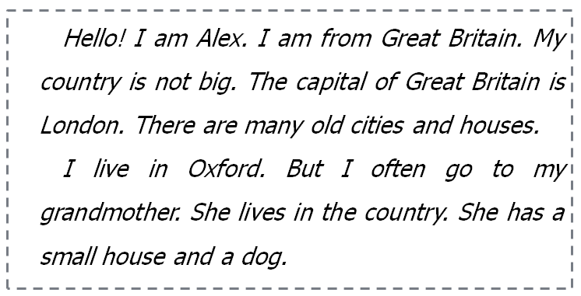

**№5. Прочитайте текст. И поставьте у предложений true или false.**

1. He name is Oleg.
2. He is from Great Britain.
3. The capital of Great Britain is Oxford.
4. He lives in the country.
5. His grandmother lives in Oxford.

**№6. Переведите на русский язык слова-маркеры.**

1. Every day - _______
2. Often - _______
3. Usually - _______
4. Now - _______
5. Tomorrow - _______



**№5. Прочитайте текст. И поставьте у предложений true или false.**

1. He name is Alex.
2. He is not from Great Britain.
3. The capital of Great Britain is London.
4. He lives in Oxford.
5. His grandmother lives in the city.

**№6. Переведите на русский язык слова-маркеры.**

1. Next week - _______
2. Every day - _______
3. Tomorrow - _______
4. Often - _______
5. Now - _______